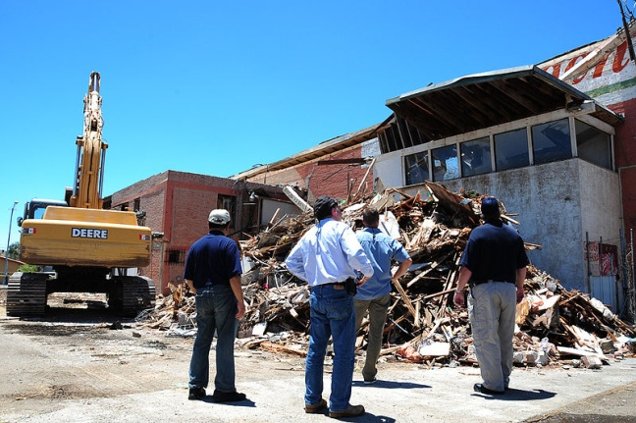
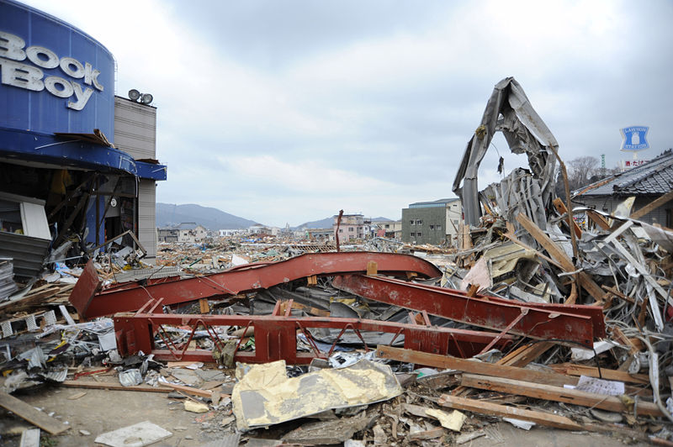
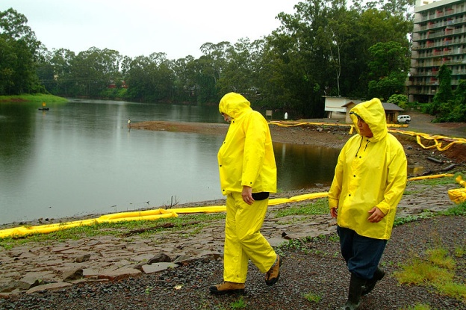

Business Continuity Plan Test

Exercise Planner Instructions

This page is intentionally blank.

The Basics of a Tabletop Exercise
A tabletop exercise (TTX) assembles key staff and decisionmakers in an informal setting intended to generate discussion of various issues regarding a hypothetical, simulated emergency incident. TTXs can be used to enhance awareness, validate plans and procedures, and/or assess the types of systems needed to guide prevention of, protection from, response to, and recovery from a defined incident.
General Characteristics
The exercise begins with a general setting which establishes the stage for the hypothetical situation. In your TTX, the facilitator stimulates discussion by providing situation updates. The updates describe major or detailed events and may be addressed either to individual participants or to participating departments or agencies. Recipients of the updates then discuss the actions they would take in response. The discussion is then facilitated with key questions that focus on roles (how the participants would respond in a real situation), plans, coordination, the effect of decisions on other organizations, and similar concerns. A TTX focuses on discussion of roles rather than simulation. In this TTX, equipment and resources are not deployed.
Application
A TTX has several important applications: the exercise lends itself to a low-stress discussion of coordination, plans, and policy; it provides a good environment for problem solving; and it provides an opportunity for key agencies and partners to become acquainted with one another, their inter-related roles, and their respective responsibilities.
Leadership
A facilitator leads the TTX discussion. This person briefs the scenario to participants, asks questions, fosters discussion, and guides the participants toward sound decisions.
Time
The agenda for your TTX is designed for approximately four hours of exercise play; however, the length is ultimately at your discretion. During the TTX, discussion times are open-ended, and participants are encouraged to take their time in arriving at in-depth decisions without time pressures. Although the facilitator maintains an awareness of time allocation for each area of discussion, the group does not have to complete every item in order for the exercise to be a success; rather, the goal is to ensure the exercise objectives are met.

This page is intentionally blank.
11 Key Steps to a Successful Exercise
Enclosed you will find everything needed to conduct a TTX that conforms to Federal Emergency Management Agency Homeland Security Exercise and Evaluation Program (HSEEP) standards. All recommended actions in this guide assume that you will begin planning three months or more before the desired TTX date.
The purpose of the Business Continuity Plan (BCP) Test is to create an opportunity for businesses to identify and examine the issues and capability gaps they are likely to face in implementing their BCPs and in recovering from business operation disruptions.

The BCP Test focuses on a facility’s recovery efforts following selected business disruptions intended to represent a broad spectrum of disruption threats: hurricane, earthquake, ice storm, and blackout. The intent is to improve the overall recovery capabilities and actions and the collective decisionmaking process. It is designed to be an open, thought-provoking exchange of ideas to help develop and expand existing knowledge of policies and procedures within the framework of BCP implementation.
Step 1: Review Documents
(Task should be accomplished three months or more prior to the actual TTX)
Below is a list of supporting exercise documents provided in your TTX:
- Exercise Planner Instructions – The instructions function as a guide for the exercise planner. This document provides step-by-step instructions on how to develop and execute the tabletop exercise.
- Situation Manual (SitMan) – The SitMan includes a detailed description of the scenario and potential questions to be used during the exercise. Throughout the exercise, participants are encouraged to use the manual to supplement the information presented and stimulate discussion.
- Presentation – These PowerPoint slides mirror the SitMan and are used by the exercise facilitator to guide participants through the scenarios and discussion questions.
- Facilitator & Evaluator Handbook (Handbook) – The handbook functions as a guide for the facilitator and evaluators. This document provides instructions and examples to properly capture information and feedback during the exercise for review and development of an After Action Report and Improvement Plan (AAR/IP).
- Participant Feedback Form – A feedback form that is utilized to gather recommendations and key outcomes from the exercise and feedback on the exercise design and conduct from the participants.
Step 2: Decide Who Is Coming
(Task should be accomplished three months or more prior to the actual TTX)
Participants may include the following:
- Players: Individuals who will respond to the situation presented, based on expert knowledge of current plans, procedures, and insights derived from training and experience.
- Observers: Individuals who will observe the exercise without directly participating in the moderated discussion.
- Facilitators: Individuals who will provide situation updates and moderate discussions. They also provide additional information or resolve questions as required.
- Evaluators: Individuals who will be responsible for gathering relevant data arising from facilitated discussions during the exercise. They will then use this information to collectively build an AAR/IP Report and Improvement Plan.
Please note that Facilitators may also assume the role of Evaluator, especially when dealing with staffing constraints.
Players must be chosen carefully to adequately represent their discipline/agency/organization and must have the authority to speak on its behalf. Based on past exercises, there are common participants, both internal and external, that may be invited depending on the complexity of a specific exercise. Organizations may initially choose to have exercises with only participants internal to the organization and include external organizations in later exercises.
Common internal players:
- Owners/management;
- Security;
- Information Technology (IT)
- Public Information Officer (PIO);
- Engineering; and
- Operations.

Common external players:
- DHS Protective Service Advisors (PSA);
- Federal/State/local law enforcement;
- State/local Office of Emergency Management (OEM) or Emergency Operations Center (EOC) personnel;
- State or local transportation agencies;
- Regulating agencies;
- Public health agencies;
- Emergency medical services and other local first responders;
- Other Federal partners; and
- International partners.

Use this list of desired attendees to send out a “save the date” pre-invitation noting the desired day (or week of the potential day) of the exercise, along with the desired location. Send this out in the form of an email or calendar invite as soon as you have your list of desired attendees (about three months before the TTX). Send a more formal invitation once the logistics are finalized (please refer to the included invitation letter).

Step 3: Logistics
(Task should be accomplished three months prior to the actual TTX)
Meeting Space
- Make sure the room is large enough to seat all desired participants and observers and is accessible to both internal and external invitees. It would be beneficial if the required space was open the evening prior to the exercise for setup and to work through any technical issues. There should also be an area for the facilitator(s) and evaluators to meet prior to and after the exercise.
- The room must also have adequate audio/video capability in order to run your presentation. Having a room with dimmable lights is a must for seeing the projector screen(s), and having at least two wireless microphones to pass around the room is recommended.
- It is always beneficial to book a backup room in case of unforeseen cancellations, etc.
Refreshments
- At your discretion, you can provide snacks, refreshments, and/or lunch. At a minimum, water and coffee are desirable. Plan with your facility/organization, or an outside vendor, accordingly.
Directions/Parking/Access
- For the upcoming invitation, you will need to provide directions to the facility. If special parking or access directions are required, you must include that as well. You can simply explain the process in words or go as far as drawing a map.
Step 4: Staffing and Layout
(Task should be accomplished two and one-half months prior to the actual TTX)
Plenary
In a plenary format, the players are organized as a single group, without regard for functional area grouping (e.g., owners, management, local representatives; facility security; engineering; law enforcement). This format requires only a single facilitator and/or evaluator, but a note-taker is also required. A co-facilitator can ease the burden of a single facilitator and help with evaluation and note-taking efforts. This format is generally best for a group of no more than 40 players, and when only a few people are available to fill the roles of facilitator, evaluator, and note-taker.
Multi-Table
Under a multi-table format, there are multiple individual tables organized by discipline or agency/organization. A lead facilitator first frames the scenario and poses discussion questions to all players. Then, group discussions occur at the individual tables, ideally facilitated by someone with functional area expertise.
Under this approach, there should be a facilitator, evaluator, and/or note-taker present in each breakout group. If feasible, it may be desirable to assign both a facilitator and a note-taker to each breakout group so that the facilitator can focus on addressing issues related to exercise objectives while the note-taker focuses on capturing general discussion issues.
Be sure to address all staff and facility access requirements and other needs in the formal invitation letter. For example, the facility being utilized for the exercise might require a “visitor request form.” In this case, you would ensure that all the external players fill out the form and return it to you well before the exercise date.
Step 5: Hold a Planning Meeting
(Task should be accomplished 2.5 months prior to the actual TTX)
It is recommended that a small planning conference be held at least two months before the actual TTX to ensure all parties’ objectives will be incorporated and to maximize the value and productivity of the exercise for all involved. The planning conference participants should include most of the lead planning authorities from the sponsoring facility/organization.
During the planning conference, participants should review the process and procedures for exercise conduct, drafts of all exercise materials, all logistical plans, and the proposed list of invitees.
Be sure to carefully plan this team, because it will be exposed to the scenario prior to the exercise and should not be expected to play. An invitation to this planning meeting will also need to be sent out at least several weeks in advance.
Step 6: Send the Formal Invitation
(Task should be accomplished two months prior to the actual TTX)
Unlike the informal “save the date” invitation, this formal invitation should come from your facility’s management in the form of either an email or signed/scanned letter. The formal invitation should include the exact date, location, time of the event, directions to facility, security/access requirements, and what kind of food/refreshments will be provided. Ensure that you send the formal invitation after holding the planning meeting; therefore, any additions/subtractions to the participants or changes to the logistics made during the planning meeting can be captured before the invitation is sent out.
Step 7: Adapt Documents
(Task should be accomplished 1.5 months prior to the actual TTX)
This TTX is unique in that it allows you to adapt the scenario to meet the objectives of your organization. The documents provided will need to be adjusted to meet your organization’s needs. Please review the SitMan for any areas highlighted in gray and the presentation for any areas highlighted in red; these areas provide an opportunity for customization and require your input. Any items that are changed in one of the products will need to be changed throughout the entire package (i.e., SitMan and PowerPoint).
Step 8: Print Documents
(Task should be accomplished one week prior to the actual TTX)
When printing documents, make sure you print one SitMan for each participant, as well as a SitMan and a Handbook for each facilitator and evaluator. Printing the presentation and reference documents for each participant is at your discretion.
Step 9: Conducting the Exercise
In a plenary format, the players are organized as a single group, without regard for functional area grouping (e.g., owners, management, and local representatives; facility security; engineering). The facilitator(s) brief the modules and moderate the questions for the entire group.
Under a multi-table format, there are multiple individual tables organized by discipline or agency/organization. A lead facilitator first frames the scenario and poses discussion questions to all players. Then, group discussions occur at the individual tables, ideally facilitated by someone with functional area expertise.
After breakout sessions take place, the entire group typically reconvenes to address any key issues, cross-disciplinary issues, or conflicting recommendations that were identified during breakout group discussions. Each breakout group briefs the key points of their discussions to the group at large. Although individual facilitators are assigned to record discussions within a designated group, all facilitators, evaluators, and/or note-takers should capture information on cross-cutting issues.
All facilitators should take and compile notes relevant to their group’s discussions. This information will be used to generate the AAR/IP and exercise notes.
Under both formats, players should discuss their responses based on their knowledge of current plans, procedures, and capabilities.
In addition, players and observers should receive a Participant Feedback Form that requests their input regarding the exercise’s strengths and areas for improvement. At a minimum, the questions on this feedback form will solicit the following:
- Impressions about exercise conduct and logistics; and
- Substantive information on the most pertinent issues discussed and potential corrective actions to address these issues.
Information collected from feedback forms contributes to the issues, observations, recommendations, and corrective actions in the AAR/IP.
Prior to the exercise, instruct the evaluators and note-takers to keep an accurate written record of what is observed. To be reliable, they should take notes as players discuss actions, make decisions, and discuss their capabilities during the exercise. Collect this information at the conclusion of the exercise as these notes will form the basis of the analysis for the AAR/IP. At the conclusion of the exercise, it is also beneficial for the after-action process to conduct a hot wash involving players, facilitators, evaluators and note-takers. Once the hot wash is finished, collect all participant feedback forms. These forms will help gauge the participants’ perspective on the exercise and will assist with the development of the AAR/IP.
For more information on the note-taking process, please refer to the Facilitator & Evaluator Handbook under the “Observing and Evaluating the Exercise” heading.
Step 10: Evaluate
(Task should be accomplished immediately after the actual TTX)
After completing the TTX, instruct the evaluators to consolidate the data collected during the exercise and transform it into narratives, or exercise write-ups, which address the course of exercise play, demonstrated strengths, and areas for improvement. A template for an exercise write-up (and analysis of the identified issues) is provided in Appendix A of the Facilitator & Evaluator Handbook.
For more information on writing up your recommendations, please refer to the Facilitator & Evaluator Handbook under the “Identify Root Causes and Develop Recommendations” heading.

Step 11: After Action Report/Improvement Plan
(Task should be accomplished 30 days after the actual TTX)
The end goal of the exercise is to produce an AAR/IP with recommendations for improving preparedness capabilities for your organization. The Improvement Plan will provide the timelines for the improvement recommendation implementations and assignments to responsible parties. Implementing this plan should be an ongoing effort by your organization.
For more information on the HSEEP AAR process and recommendations, please refer to the Facilitator & Evaluator Handbook under the AAR/IP heading.

This page intentionally blank.

